Participants’ Information

The 4th CJK NGN Meeting
June 24, 2005
Guangzhou Hotel, Beijing, China

Venue and Duration
China Communications Standards Association have the honor to invite the participants to the 4th CJK NGN Meeting, which will be held in Guangzhou Hotel, Beijing June 24, 2005.

GUANGZHOU HOTEL
No.A3, Xi Dan Heng Er Tiao,
Xicheng District, Beijing,
China
Tel: +86 10 66078866
Fax: +86 10 66085998
Post Code: 100031
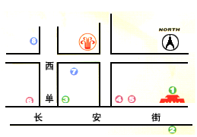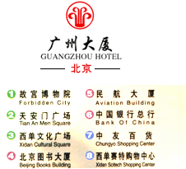

Transfers from Airport
Guangzhou Hotel is located in the downtown area and the center of Beijing, approximately 30 kilometers from the airport. A taxi fare from the airport to the city center (the meeting venue) is around RMB130.00 – 150.00 yuan. A shuttle-bus (take off at the bus station “Xi Dan”)fare is currently RMB16.00 yuan.

Hotel Accommodation
The participants are recommended to live in Guangzhou Hotel.
Room Rate: To be confirmed
The local secretariat will coordinate booking of all hotel rooms for participants.

Electrical Socket Design
The standard power supply in China is 220 Volts 50 Hz. Please bring the appropriate adapters and converters.

3 pin socket

Airport Tax
Airport Tax is RMB90.00 yuan.

Insurance
The participants are requested to kindly make necessary arrangements for insurance and medical coverage before travel.

Meeting Registration / Hotel Room Reservation Form
4th CJK NGN Meeting
June 24, 2005

Please complete a separate form for each delegate and return by June 1st, 2005 to:
Mr. Zhao Shizhuo Tel: +86-10-62302645
Fax: +86-10-62301849
Email: Zhaosz@ccsa.org.cn

First Name: ____________________________

Family Name: ___________________________

Country: __________________________

Company: _____ ___________________

Address: ___

Tel: ___________________

Fax: ___________________

Email: __ ______

Hotel Room Reservation
Check-in date:
Check-out date:
Number of nights: ___

Flight information
Arrival: ______
Departure: ______

Special requests if any:

